UNIVERSITY OF SCIENCE AND TECHNOLOGY OF HANOI

**UNDERGRADUATE SCHOOL**



Research and Development

**BACHELOR THESIS**

By

Student name

Student specialty

Title:

AAA

Supervisors: Prof. Dr. NGUYỄN VĂN A

Lab name

Prof. Dr. NGUYỄN VĂN B

Lab name

**Hanoi, July 2022**

Hanoi, September 2013

**HàNội, Sept. 2012**

TABLE OF CONTENTS

ACKNOWLEDGEMENTS 2

LIST OF ABBREVIATIONS 3

LIST OF TABLES 4

LIST OF FIGURES 5

ABSTRACT 6

I/ INTRODUCTION 7

II/ OBJECTIVES 8

III/ MATERIALS AND METHODS 9

IV/ RESULTS AND DISCUSSIONS 10

V/ CONCLUSION 13

REFERENCES 14

APPENDICES 1

# ACKNOWLEDGEMENTS

**Example of acknowledgements**

“I would like to express my gratitude to all those who gave me possibility to complete this thesis in specific as well as academic supporting in general that I received during the time of my studying at the University of Science and Technology of Hanoi.

Foremost, I would like to send my honest thanks to my supervisor...”

# LIST OF ABBREVIATIONS

**Example of list of abbreviations**

|  |  |
| --- | --- |
| BP | Biotechnology- Pharmacology |
| CMOS | Complementary Metal-Oxide-Semiconductor |
| CMRR | Common-Mode Rejection Ratio |
| ICT | Information and Communication Technology |
| NMC | Nested Miller Compensation |
| GB | Gain Bandwidth |
| USTH | University of Science and Technology of Hanoi |

# LIST OF TABLES

**Example of list of tables**

Table 1:Topographic parameters measured for the 15 gully heads in 2009 …………….9

Table 2:Simulation setup .................................................................................................10

# LIST OF FIGURES

**Example of list of figures**

Figure 1: Hexagon group-based deployment mode ..........................................................10

Figure 2: Smoothed tree density and tree canopy area in the catchment from 1945 to 2009………………………………………………………………………………………11

# ABSTRACT

(No more than 250 words, in English + 6 key words)

**Example of abstract**

We present a fully-integrated compact (1.1 mm2) target device for Near Field Communication (NFC). The design of the key analog part of the tag IC is presented, which includes a robust demodulator for 10% ASK envelope detection, a high quality random number generator, an adaptive RF limiter, and a low power clock generator. A 128 bit advanced encryption standard (AES) with new cyclic key generation is used for secure data encryption and decryption. An on-chip 4Kb EEPROM is used to support the AES operation. The tag chip is fabricated in a 1-poly 6-metal low-power (LP) 0.18 μm CMOS process with a CoSi2-Schottky diode and EEPROM process.

Key words: Near Field Communication, ASK, AES, low power, Schottky diode, EEPROM process.

# I/ INTRODUCTION

(Global context, literature review, main questions and objectives including the presentation of the problem with the scientific background, 2-3 pages)

# II/ OBJECTIVES

Scientific objective of the internship: submit your goal and summarize the strategy in 2-3 concise sentences

# III/ MATERIALS AND METHODS

(Presenting in this section the materials and the methods you have used. Methods have to be presented not in the form of a bench protocol but rather in a style suitable for publication (a paragraph of complete sentences) and include all information necessary for a third person to reproduce your experiments (in detail but condensed))

# IV/ RESULTS AND DISCUSSIONS

1. **Results:** Description of the student's own research, procedures and results. Interpretation of the student's results; conclusions and review of the results comparison with other research; critical assessment of the student's own work; limitation of the study).
2. **Discussion:** in this section you have to do a critical analysis and discuss the results you obtained in regards to the data already available in the scientific literature. In case of failure you have to analyze the reasons and propose an alternative strategy. In case of success you have to state the essential new information your work has given to solve the scientific problem and about the immediate perspective that it opens.

**Example of table to present your results (always choose between table or figure)**

**Table 1:Topographic parameters measured for the 15 gully heads in 2009**

|  |  |  |  |  |  |  |  |  |  |  |
| --- | --- | --- | --- | --- | --- | --- | --- | --- | --- | --- |
| **GULLY NUMBER** | **Drain.A**  (m2) | **DAslope**  (%) | **LHS**  (%) | **SPI** | **GL**  (m) | **GHA**  (m2) | **GVol**  (m3) | **RL**  (m y-1) | **Retreat.A**  (m2 y-1) | **V**  (m3 y-1) |
| **1** | 41258 | 28.4 | 17.3 | 3.78 | 120 | 4844 | 7673 | 0.67 | 68.6 | 218 |
| **2** | 85597 | 29.4 | 30.1 | 5.39 | 225 | 11695 | 28096 | 0.33 | 202.0 | 727 |
| **3** | 8490 | 12.1 | 10.2 | 3.05 | 98 | 2258 | 2090 | 1.33 | 56.3 | 150 |
| **4** | 105150 | 30.9 | 12.2 | 3.83 | 218 | 8101 | 53650 | 0.33 | 56.6 | 358 |
| **5** | 26467 | 18.8 | 6.4 | 2.26 | 143 | 4175 | 22030 | 0.33 | 14.6 | 69 |
| **6** | 13054 | 18.8 | 12.9 | 3.56 | 68 | 875 | 1998 | 0.33 | 4.0 | 11 |
| **7** | 17412 | 26.7 | 13.9 | 3.82 | 69 | 809 | 1459 | 0.67 | 19.0 | 64 |
| **8** | 14350 | 17.7 | 8.8 | 4.78 | 71 | 1393 | 1875 | 1.33 | 38.6 | 122 |
| **9** | 103776 | 24.2 | 10.0 | 1.89 | 240 | 12008 | 79928 | 1.33 | 163.6 | 1303 |
| **10** | 3701 | 12.9 | 8.7 | 1.69 | 65 | 1795 | 4235 | 0.67 | 52.6 | 266 |
| **11** | 2790 | 9.1 | 5.4 | 0.79 | 57 | 555 | 423 | 0.33 | 15.0 | 17 |
| **12** | 57941 | 30.4 | 9.1 | 4.14 | 63 | 1196 | 4429 | 1.00 | 33.0 | 157 |
| **13** | 38924 | 28.2 | 7.1 | 3.17 | 132 | 3585 | 23642 | 1.67 | 113.0 | 897 |
| **14** | 9240 | 36.4 | 15.7 | 3.30 | 73 | 1292 | 2995 | 0.67 | 43.6 | 156 |
| **15** | 3039 | 10.5 | 12.2 | 1.87 | 64 | 911 | 1922 | 0.67 | 35.0 | 123 |
| **mean** | 35412 | 22.3 | 12.0 | 3.20 | 113 | 3699 | 15763 | 0.77 | 61.0 | 309 |
| **SD** | 36336 | 8.6 | 6.0 | 1.05 | 64 | 3881 | 23140 | 0.44 | 56.5 | 374 |

**Table 2: Simulation setup**

|  |  |  |
| --- | --- | --- |
| **Symbol** | **Value** | **Description** |
| **N** | 10,000 | Number of nodes in the network |
| **S** | 1000x1000(m2) | Network deployment area |
| **r** | 40m | The communication range |
| **M** | 200 keys | The memory size of nodes for storing key materials. |
| **Ϭ** | 50m | The standard deviation in Gaussian distribution. |

**Example of figure to present your results:**

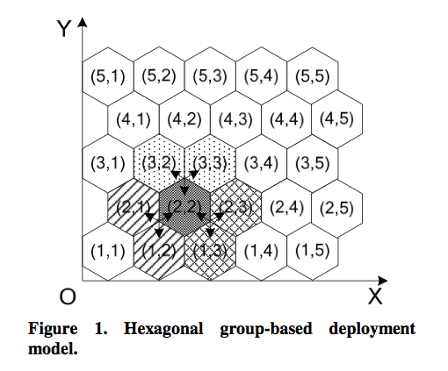

**Figure 1: Hexagon group-based deployment model**

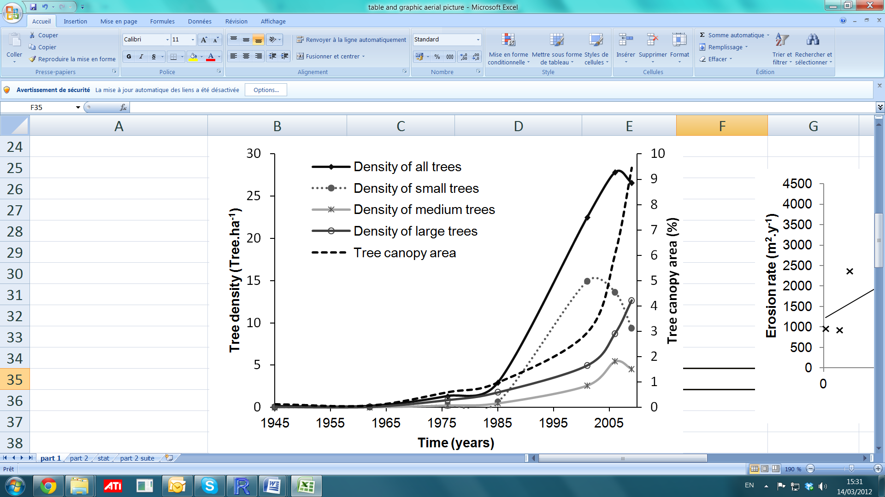

**Figure 2: Smoothed tree density and tree canopy area in the catchment from 1945 to 2009**

Smoothed tree density and tree canopy area in the catchment from 1945 to 2009. Small trees (canopy area < 1 m2), medium-sized trees (1 m2< canopy area< 15 m2), large trees (canopy area> 15 m2).

***Note: Never start your result section with a Fig or Table only. An introduction paragraph should be added.***

# V/ CONCLUSION

The conclusion recapitulates the main achievements of your work and the main perspectives it opens.

# REFERENCES

*References need to be ordered by the alphabet (A → Z). Any cited reference follows the template as followings:*

*If it is a cited article, you should use the following format:*

[Clarke] R. J. Clarke, J. H. Coates and S. F. Lincoln. Kinetics and equilibrium studies of cyclo-malto-octaose (g-cyclodextrin)-methyl orange inclusion complexes. Carbohydr. Res. 127 (1984) 181-191.

[Sanger]Sanger J, Nicklen S, Coulson AR (1977) DNA sequencing with the chain-termination inhibitors. *Proc Natl AcadSci USA* 74: 5463-5467.

*If it is a cited book, you should use the following format:*

[Sambrook] Sambrook J, Russell DW (2001) *Molecular Cloning. A Laboratory Manual*, 3rd ed. Cold Spring Harbor Laboratory, Cold Spring Harbor, NY.

[Voytas] Voytas DF, Boeke JD (2002) *Tyl and Ty5 of Saccharomyces cerevisiae*. In Craig NL, Claigie R, Gellert M, Lambowitz AM, eds. *Mobile DNA II*. ASM Press, Washington, DC: 631-632.

*If it is a* **Thesis/Dissertations***, you should use the following format:*

[Yale]Santanen A. Yale, (2000) Polyamine metabolism during development of somatic and zygotic embryos of *Piceaabies*. *PhD dissertation*. Department ofBiociences, University of Helsinki, Finland.

# APPENDICES

**APPENDIX 1**

**APPENDIX 2**